УО «Белорусский государственный университет информатики и радиоэлектроники»
Кафедра ПОИТ

Отчет по лабораторной работе №2
по предмету «Теория информации»
Вариант 3
Выполнила:
Аврусевич В.В.
гр. 451003
Проверила:
Болтак С.В.

Минск 2026
Задание:
Вариант 3.
Реализовать систему потокового шифрования и дешифрования для файла с любым содержимым (с любым расширением) с помощью генератора ключевой последовательности на основе линейного сдвигового регистра с обратной связью LFSR.
Размерность регистра 25. Многочлен $x^{25}+ x^{3}+1$.

Скриншоты, подтверждающие работу программы:

- Расширение .mp4 (в регистре – все единицы).
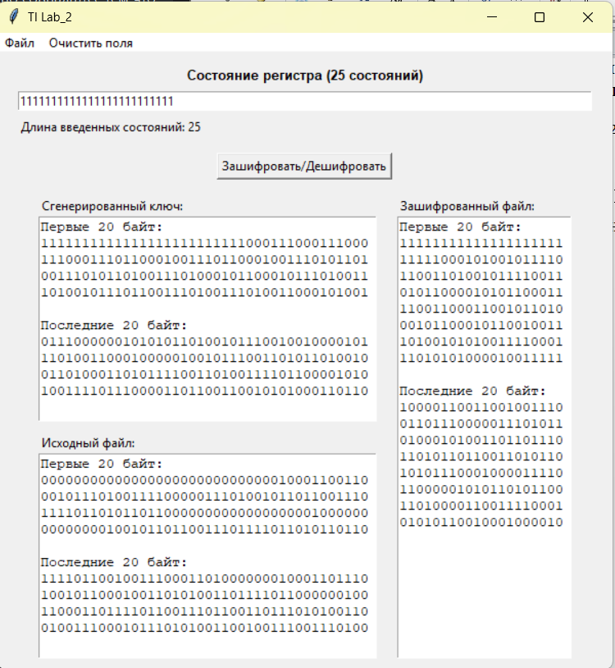

Зашифрованный файл:
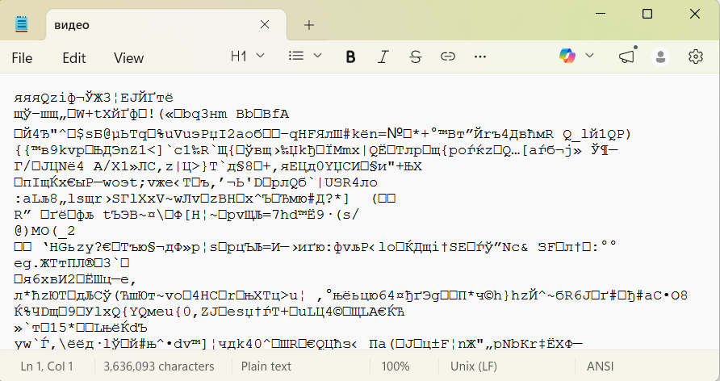

Расшифрованный файл:
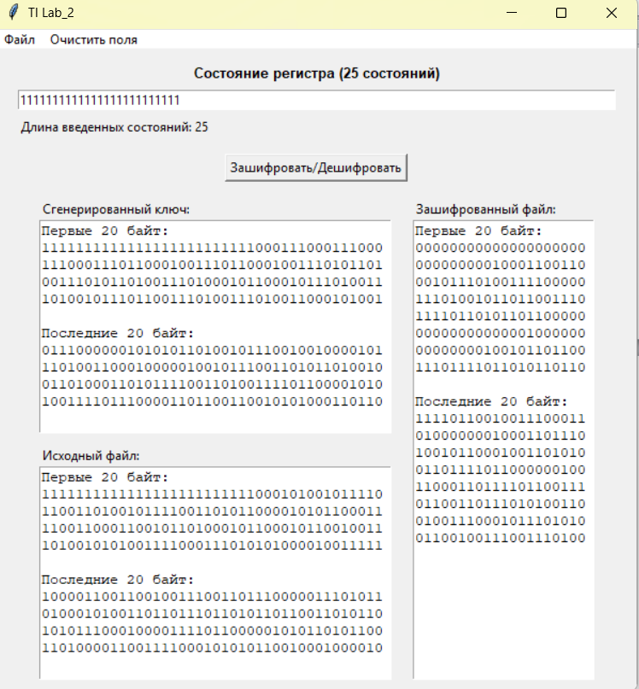
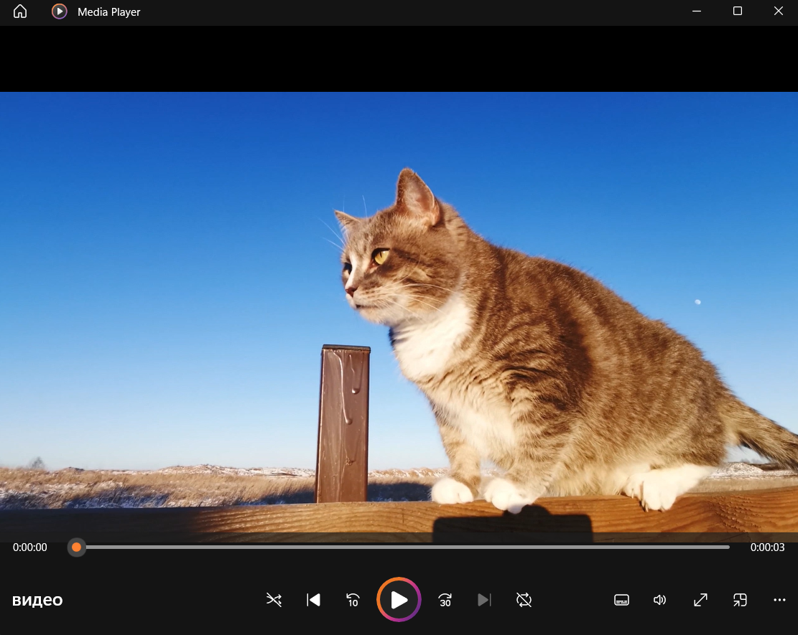

- Расширение .mp3.
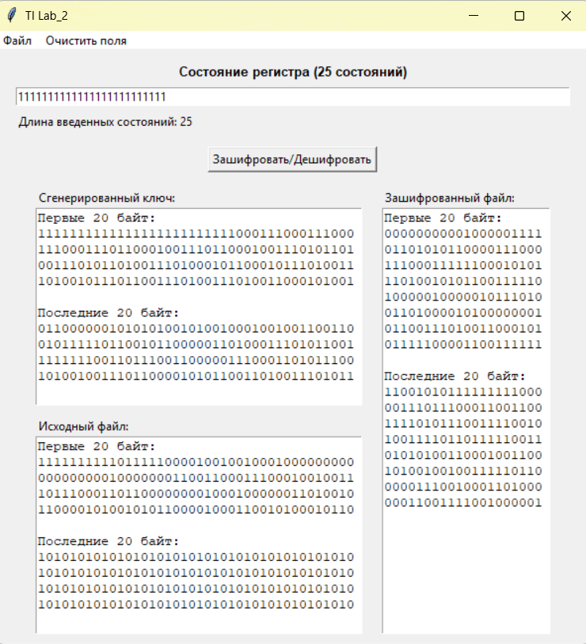
Зашифрованный файл:
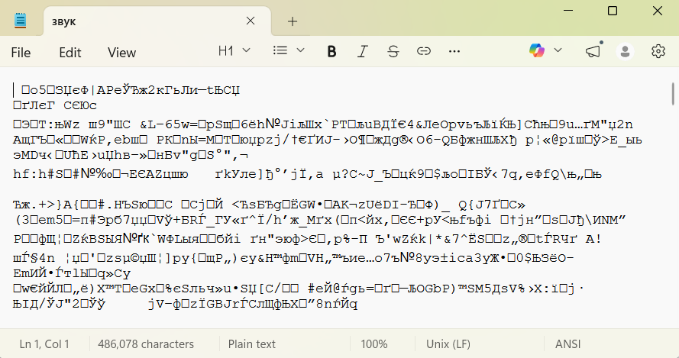
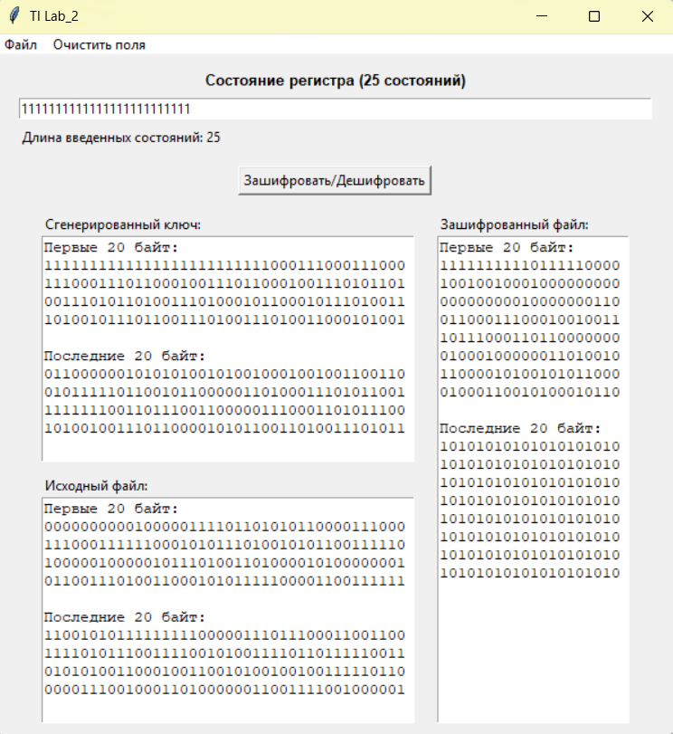
Расшифрованный файл:

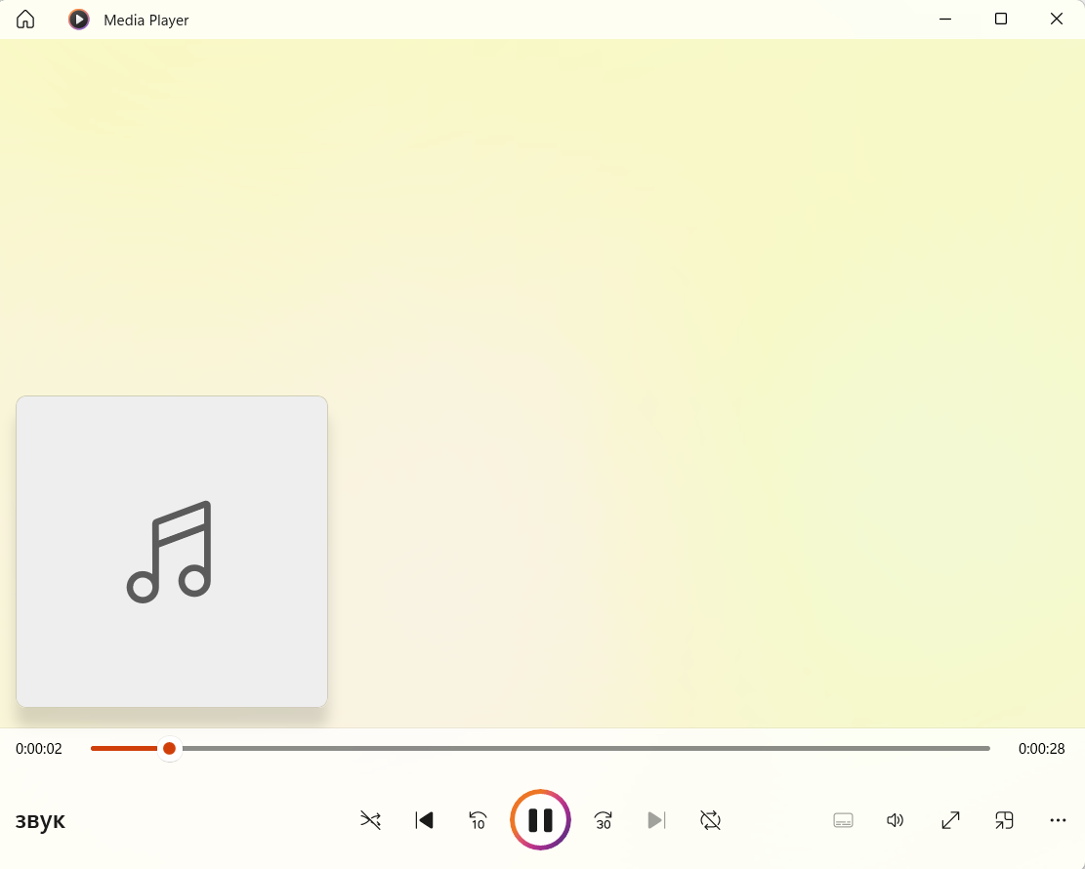
- Расширение .jpg.
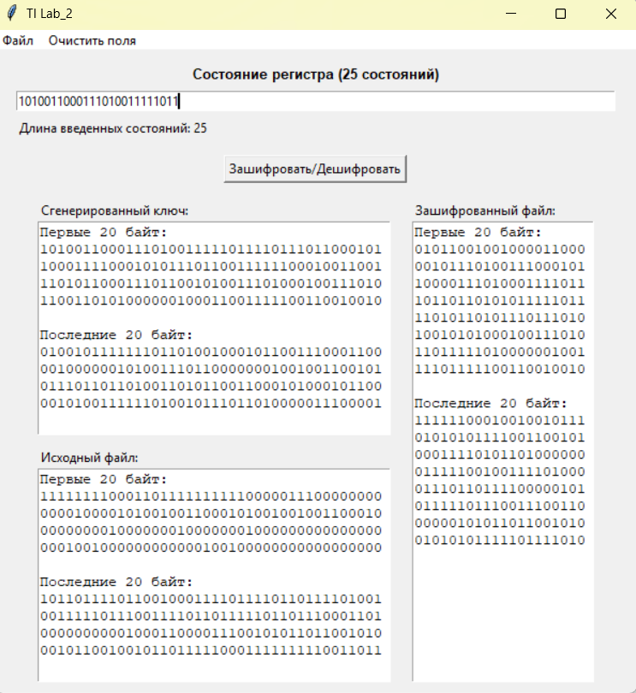

Зашифрованный файл:
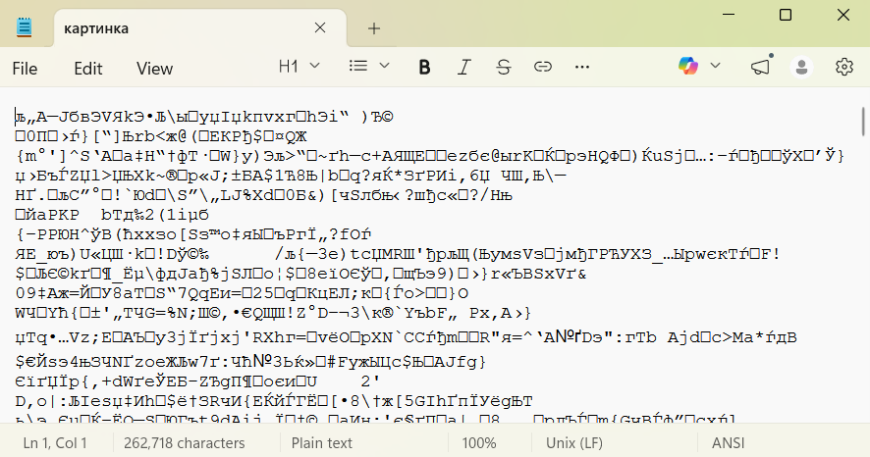

Расшифрованный файл:
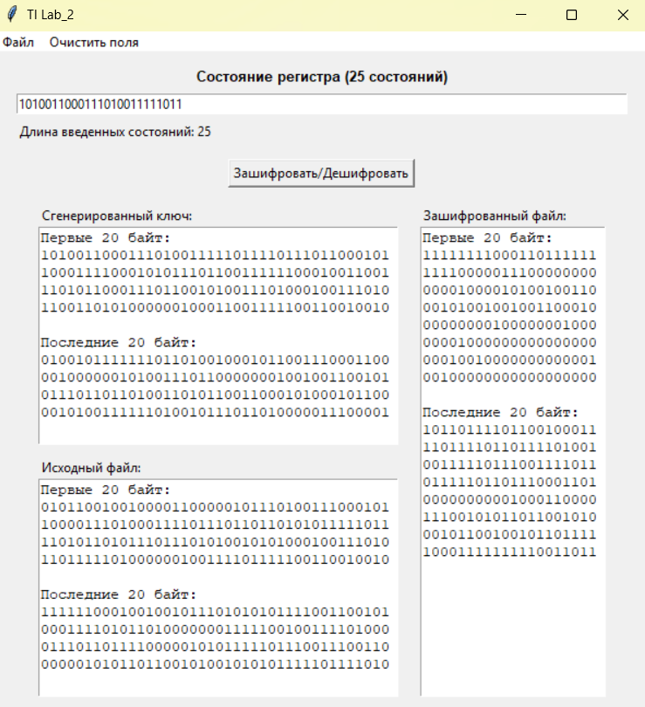
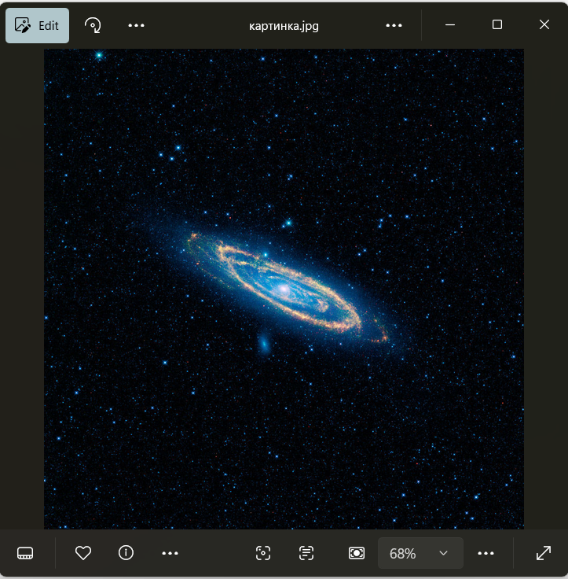

- Расширение .txt.
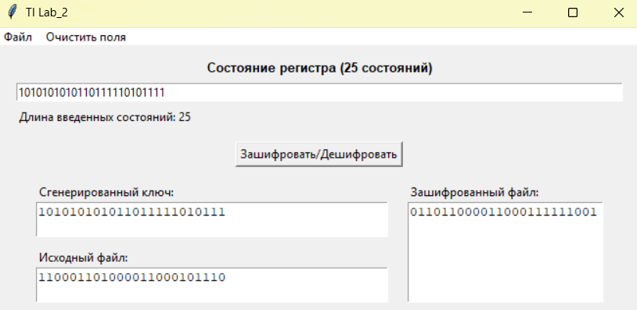
Зашифрованный файл:

Расшифрованный файл:
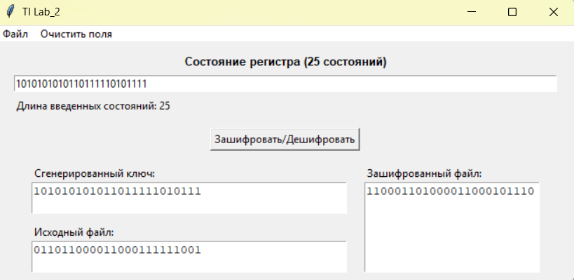

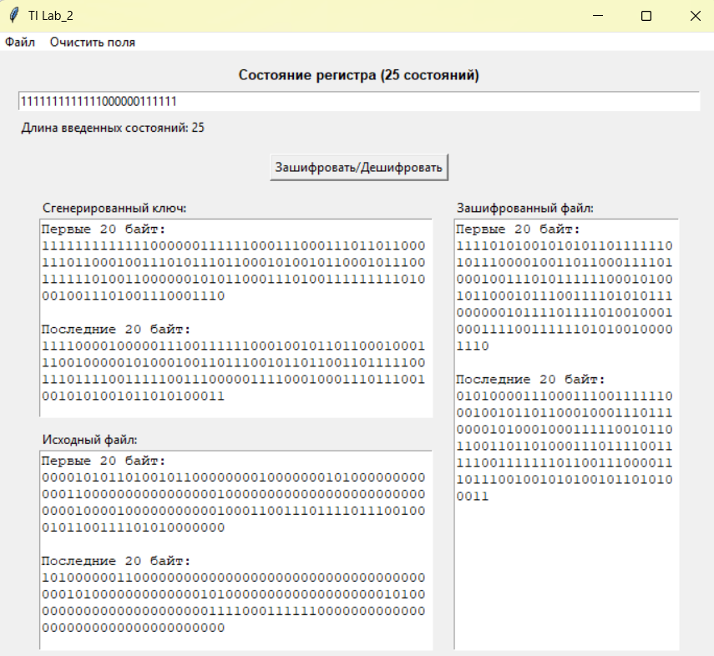
- Расширение .xlsx.

Зашифрованный файл:
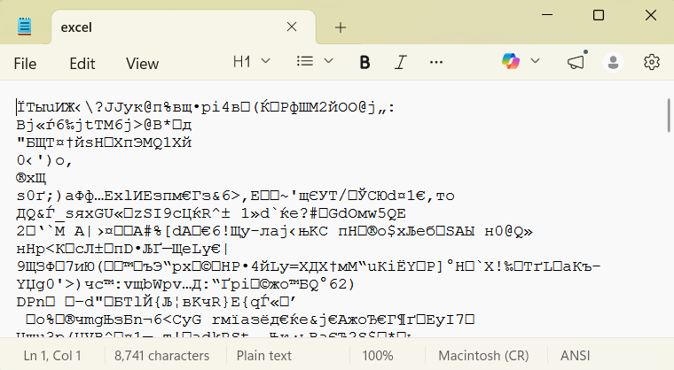
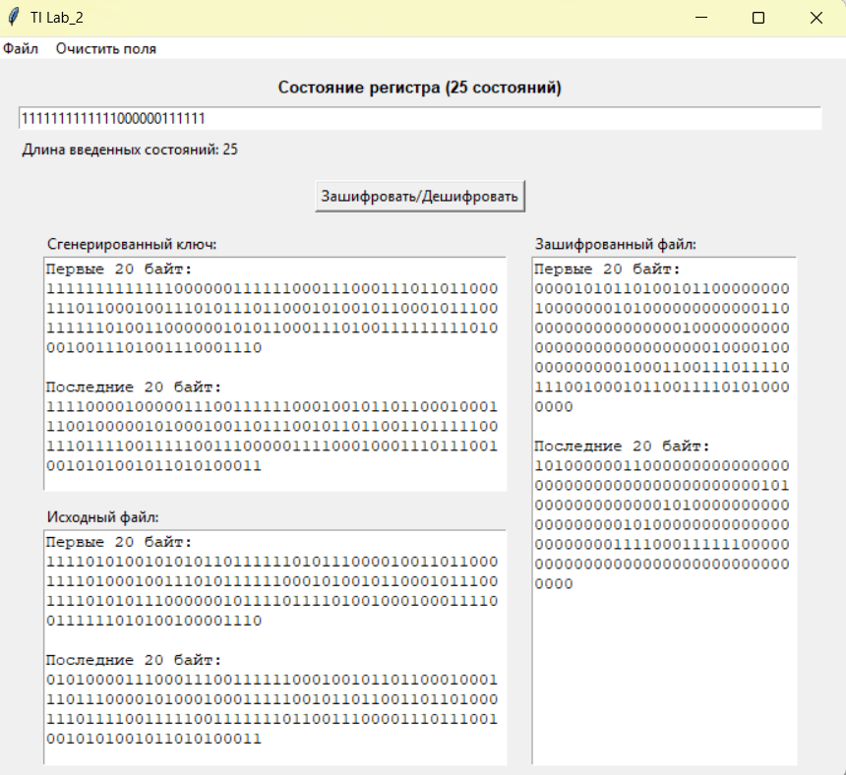
Расшифрованный файл:

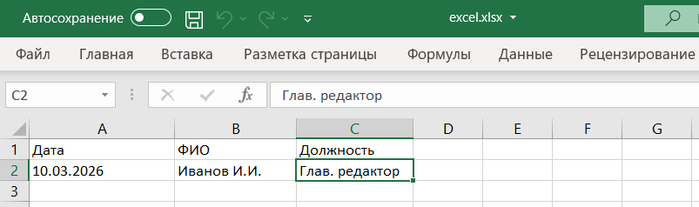

Пример работы алгоритма при заполнении регистра единицами
 |  | Степени |  |  |  |  |  |  |  |  |  |  |  |  |  |  |  |  |  |  |  |  |  |  |  |  | xor
 |  | 25 | 24 | 23 | 22 | 21 | 20 | 19 | 18 | 17 | 16 | 15 | 14 | 13 | 12 | 11 | 10 | 9 | 8 | 7 | 6 | 5 | 4 | 3 | 2 | 1
Шаг / Состояние регистра | 1 | 1 | 1 | 1 | 1 | 1 | 1 | 1 | 1 | 1 | 1 | 1 | 1 | 1 | 1 | 1 | 1 | 1 | 1 | 1 | 1 | 1 | 1 | 1 | 1 | 1 | 0
 | 2 | 1 | 1 | 1 | 1 | 1 | 1 | 1 | 1 | 1 | 1 | 1 | 1 | 1 | 1 | 1 | 1 | 1 | 1 | 1 | 1 | 1 | 1 | 1 | 1 | 0 | 0
 | 3 | 1 | 1 | 1 | 1 | 1 | 1 | 1 | 1 | 1 | 1 | 1 | 1 | 1 | 1 | 1 | 1 | 1 | 1 | 1 | 1 | 1 | 1 | 1 | 0 | 0 | 0
 | 4 | 1 | 1 | 1 | 1 | 1 | 1 | 1 | 1 | 1 | 1 | 1 | 1 | 1 | 1 | 1 | 1 | 1 | 1 | 1 | 1 | 1 | 1 | 0 | 0 | 0 | 1
 | 5 | 1 | 1 | 1 | 1 | 1 | 1 | 1 | 1 | 1 | 1 | 1 | 1 | 1 | 1 | 1 | 1 | 1 | 1 | 1 | 1 | 1 | 0 | 0 | 0 | 1 | 1
 | 6 | 1 | 1 | 1 | 1 | 1 | 1 | 1 | 1 | 1 | 1 | 1 | 1 | 1 | 1 | 1 | 1 | 1 | 1 | 1 | 1 | 0 | 0 | 0 | 1 | 1 | 1
 | 7 | 1 | 1 | 1 | 1 | 1 | 1 | 1 | 1 | 1 | 1 | 1 | 1 | 1 | 1 | 1 | 1 | 1 | 1 | 1 | 0 | 0 | 0 | 1 | 1 | 1 | 0
 | 8 | 1 | 1 | 1 | 1 | 1 | 1 | 1 | 1 | 1 | 1 | 1 | 1 | 1 | 1 | 1 | 1 | 1 | 1 | 0 | 0 | 0 | 1 | 1 | 1 | 0 | 0
 | 9 | 1 | 1 | 1 | 1 | 1 | 1 | 1 | 1 | 1 | 1 | 1 | 1 | 1 | 1 | 1 | 1 | 1 | 0 | 0 | 0 | 1 | 1 | 1 | 0 | 0 | 0
 | 10 | 1 | 1 | 1 | 1 | 1 | 1 | 1 | 1 | 1 | 1 | 1 | 1 | 1 | 1 | 1 | 1 | 0 | 0 | 0 | 1 | 1 | 1 | 0 | 0 | 0 | 1
 | 11 | 1 | 1 | 1 | 1 | 1 | 1 | 1 | 1 | 1 | 1 | 1 | 1 | 1 | 1 | 1 | 0 | 0 | 0 | 1 | 1 | 1 | 0 | 0 | 0 | 1 | 1
 | 12 | 1 | 1 | 1 | 1 | 1 | 1 | 1 | 1 | 1 | 1 | 1 | 1 | 1 | 1 | 0 | 0 | 0 | 1 | 1 | 1 | 0 | 0 | 0 | 1 | 1 | 1
 | 13 | 1 | 1 | 1 | 1 | 1 | 1 | 1 | 1 | 1 | 1 | 1 | 1 | 1 | 0 | 0 | 0 | 1 | 1 | 1 | 0 | 0 | 0 | 1 | 1 | 1 | 0
 | 14 | 1 | 1 | 1 | 1 | 1 | 1 | 1 | 1 | 1 | 1 | 1 | 1 | 0 | 0 | 0 | 1 | 1 | 1 | 0 | 0 | 0 | 1 | 1 | 1 | 0 | 0
 | 15 | 1 | 1 | 1 | 1 | 1 | 1 | 1 | 1 | 1 | 1 | 1 | 0 | 0 | 0 | 1 | 1 | 1 | 0 | 0 | 0 | 1 | 1 | 1 | 0 | 0 | 0
 | 16 | 1 | 1 | 1 | 1 | 1 | 1 | 1 | 1 | 1 | 1 | 0 | 0 | 0 | 1 | 1 | 1 | 0 | 0 | 0 | 1 | 1 | 1 | 0 | 0 | 0 | 1
 | 17 | 1 | 1 | 1 | 1 | 1 | 1 | 1 | 1 | 1 | 0 | 0 | 0 | 1 | 1 | 1 | 0 | 0 | 0 | 1 | 1 | 1 | 0 | 0 | 0 | 1 | 1
 | 18 | 1 | 1 | 1 | 1 | 1 | 1 | 1 | 1 | 0 | 0 | 0 | 1 | 1 | 1 | 0 | 0 | 0 | 1 | 1 | 1 | 0 | 0 | 0 | 1 | 1 | 1
 | 19 | 1 | 1 | 1 | 1 | 1 | 1 | 1 | 0 | 0 | 0 | 1 | 1 | 1 | 0 | 0 | 0 | 1 | 1 | 1 | 0 | 0 | 0 | 1 | 1 | 1 | 0
 | 20 | 1 | 1 | 1 | 1 | 1 | 1 | 0 | 0 | 0 | 1 | 1 | 1 | 0 | 0 | 0 | 1 | 1 | 1 | 0 | 0 | 0 | 1 | 1 | 1 | 0 | 0
 | 21 | 1 | 1 | 1 | 1 | 1 | 0 | 0 | 0 | 1 | 1 | 1 | 0 | 0 | 0 | 1 | 1 | 1 | 0 | 0 | 0 | 1 | 1 | 1 | 0 | 0 | 0
 | 22 | 1 | 1 | 1 | 1 | 0 | 0 | 0 | 1 | 1 | 1 | 0 | 0 | 0 | 1 | 1 | 1 | 0 | 0 | 0 | 1 | 1 | 1 | 0 | 0 | 0 | 1
 | 23 | 1 | 1 | 1 | 0 | 0 | 0 | 1 | 1 | 1 | 0 | 0 | 0 | 1 | 1 | 1 | 0 | 0 | 0 | 1 | 1 | 1 | 0 | 0 | 0 | 1 | 1
 | 24 | 1 | 1 | 0 | 0 | 0 | 1 | 1 | 1 | 0 | 0 | 0 | 1 | 1 | 1 | 0 | 0 | 0 | 1 | 1 | 1 | 0 | 0 | 0 | 1 | 1 | 1
 | 25 | 1 | 0 | 0 | 0 | 1 | 1 | 1 | 0 | 0 | 0 | 1 | 1 | 1 | 0 | 0 | 0 | 1 | 1 | 1 | 0 | 0 | 0 | 1 | 1 | 1 | 0
 | 26 | 0 | 0 | 0 | 1 | 1 | 1 | 0 | 0 | 0 | 1 | 1 | 1 | 0 | 0 | 0 | 1 | 1 | 1 | 0 | 0 | 0 | 1 | 1 | 1 | 0 | 1
 | 27 | 0 | 0 | 1 | 1 | 1 | 0 | 0 | 0 | 1 | 1 | 1 | 0 | 0 | 0 | 1 | 1 | 1 | 0 | 0 | 0 | 1 | 1 | 1 | 0 | 1 | 1
 | 28 | 0 | 1 | 1 | 1 | 0 | 0 | 0 | 1 | 1 | 1 | 0 | 0 | 0 | 1 | 1 | 1 | 0 | 0 | 0 | 1 | 1 | 1 | 0 | 1 | 1 | 0
 | 29 | 1 | 1 | 1 | 0 | 0 | 0 | 1 | 1 | 1 | 0 | 0 | 0 | 1 | 1 | 1 | 0 | 0 | 0 | 1 | 1 | 1 | 0 | 1 | 1 | 0 | 0
 | 30 | 1 | 1 | 0 | 0 | 0 | 1 | 1 | 1 | 0 | 0 | 0 | 1 | 1 | 1 | 0 | 0 | 0 | 1 | 1 | 1 | 0 | 1 | 1 | 0 | 0 | 0
 | 31 | 1 | 0 | 0 | 0 | 1 | 1 | 1 | 0 | 0 | 0 | 1 | 1 | 1 | 0 | 0 | 0 | 1 | 1 | 1 | 0 | 1 | 1 | 0 | 0 | 0 | 1
 | 32 | 0 | 0 | 0 | 1 | 1 | 1 | 0 | 0 | 0 | 1 | 1 | 1 | 0 | 0 | 0 | 1 | 1 | 1 | 0 | 1 | 1 | 0 | 0 | 0 | 1 | 0
 | 33 | 0 | 0 | 1 | 1 | 1 | 0 | 0 | 0 | 1 | 1 | 1 | 0 | 0 | 0 | 1 | 1 | 1 | 0 | 1 | 1 | 0 | 0 | 0 | 1 | 0 | 0
 | 34 | 0 | 1 | 1 | 1 | 0 | 0 | 0 | 1 | 1 | 1 | 0 | 0 | 0 | 1 | 1 | 1 | 0 | 1 | 1 | 0 | 0 | 0 | 1 | 0 | 0 | 1
 | 35 | 1 | 1 | 1 | 0 | 0 | 0 | 1 | 1 | 1 | 0 | 0 | 0 | 1 | 1 | 1 | 0 | 1 | 1 | 0 | 0 | 0 | 1 | 0 | 0 | 1 | 1
 | 36 | 1 | 1 | 0 | 0 | 0 | 1 | 1 | 1 | 0 | 0 | 0 | 1 | 1 | 1 | 0 | 1 | 1 | 0 | 0 | 0 | 1 | 0 | 0 | 1 | 1 | 1
 | 37 | 1 | 0 | 0 | 0 | 1 | 1 | 1 | 0 | 0 | 0 | 1 | 1 | 1 | 0 | 1 | 1 | 0 | 0 | 0 | 1 | 0 | 0 | 1 | 1 | 1 | 0
 | 38 | 0 | 0 | 0 | 1 | 1 | 1 | 0 | 0 | 0 | 1 | 1 | 1 | 0 | 1 | 1 | 0 | 0 | 0 | 1 | 0 | 0 | 1 | 1 | 1 | 0 | 1
 | 39 | 0 | 0 | 1 | 1 | 1 | 0 | 0 | 0 | 1 | 1 | 1 | 0 | 1 | 1 | 0 | 0 | 0 | 1 | 0 | 0 | 1 | 1 | 1 | 0 | 1 | 1
 | 40 | 0 | 1 | 1 | 1 | 0 | 0 | 0 | 1 | 1 | 1 | 0 | 1 | 1 | 0 | 0 | 0 | 1 | 0 | 0 | 1 | 1 | 1 | 0 | 1 | 1 | 0
 | 41 | 1 | 1 | 1 | 0 | 0 | 0 | 1 | 1 | 1 | 0 | 1 | 1 | 0 | 0 | 0 | 1 | 0 | 0 | 1 | 1 | 1 | 0 | 1 | 1 | 0 | 0
 | 42 | 1 | 1 | 0 | 0 | 0 | 1 | 1 | 1 | 0 | 1 | 1 | 0 | 0 | 0 | 1 | 0 | 0 | 1 | 1 | 1 | 0 | 1 | 1 | 0 | 0 | 0
 | 43 | 1 | 0 | 0 | 0 | 1 | 1 | 1 | 0 | 1 | 1 | 0 | 0 | 0 | 1 | 0 | 0 | 1 | 1 | 1 | 0 | 1 | 1 | 0 | 0 | 0 | 1
 | 44 | 0 | 0 | 0 | 1 | 1 | 1 | 0 | 1 | 1 | 0 | 0 | 0 | 1 | 0 | 0 | 1 | 1 | 1 | 0 | 1 | 1 | 0 | 0 | 0 | 1 | 0
 | 45 | 0 | 0 | 1 | 1 | 1 | 0 | 1 | 1 | 0 | 0 | 0 | 1 | 0 | 0 | 1 | 1 | 1 | 0 | 1 | 1 | 0 | 0 | 0 | 1 | 0 | 0
 | 46 | 0 | 1 | 1 | 1 | 0 | 1 | 1 | 0 | 0 | 0 | 1 | 0 | 0 | 1 | 1 | 1 | 0 | 1 | 1 | 0 | 0 | 0 | 1 | 0 | 0 | 1
 | 47 | 1 | 1 | 1 | 0 | 1 | 1 | 0 | 0 | 0 | 1 | 0 | 0 | 1 | 1 | 1 | 0 | 1 | 1 | 0 | 0 | 0 | 1 | 0 | 0 | 1 | 1
 | 48 | 1 | 1 | 0 | 1 | 1 | 0 | 0 | 0 | 1 | 0 | 0 | 1 | 1 | 1 | 0 | 1 | 1 | 0 | 0 | 0 | 1 | 0 | 0 | 1 | 1 | 1
 | 49 | 1 | 0 | 1 | 1 | 0 | 0 | 0 | 1 | 0 | 0 | 1 | 1 | 1 | 0 | 1 | 1 | 0 | 0 | 0 | 1 | 0 | 0 | 1 | 1 | 1 | 0
 | 50 | 0 | 1 | 1 | 0 | 0 | 0 | 1 | 0 | 0 | 1 | 1 | 1 | 0 | 1 | 1 | 0 | 0 | 0 | 1 | 0 | 0 | 1 | 1 | 1 | 0 | 1
 | 51 | 1 | 1 | 0 | 0 | 0 | 1 | 0 | 0 | 1 | 1 | 1 | 0 | 1 | 1 | 0 | 0 | 0 | 1 | 0 | 0 | 1 | 1 | 1 | 0 | 1 | 0
 | 52 | 1 | 0 | 0 | 0 | 1 | 0 | 0 | 1 | 1 | 1 | 0 | 1 | 1 | 0 | 0 | 0 | 1 | 0 | 0 | 1 | 1 | 1 | 0 | 1 | 0 | 1
 | 53 | 0 | 0 | 0 | 1 | 0 | 0 | 1 | 1 | 1 | 0 | 1 | 1 | 0 | 0 | 0 | 1 | 0 | 0 | 1 | 1 | 1 | 0 | 1 | 0 | 1 | 1
 | 54 | 0 | 0 | 1 | 0 | 0 | 1 | 1 | 1 | 0 | 1 | 1 | 0 | 0 | 0 | 1 | 0 | 0 | 1 | 1 | 1 | 0 | 1 | 0 | 1 | 1 | 0
 | 55 | 0 | 1 | 0 | 0 | 1 | 1 | 1 | 0 | 1 | 1 | 0 | 0 | 0 | 1 | 0 | 0 | 1 | 1 | 1 | 0 | 1 | 0 | 1 | 1 | 0 | 1
 | 56 | 1 | 0 | 0 | 1 | 1 | 1 | 0 | 1 | 1 | 0 | 0 | 0 | 1 | 0 | 0 | 1 | 1 | 1 | 0 | 1 | 0 | 1 | 1 | 0 | 1 | 0

